EASY AND CONVENIENT ACCESS

TRANSPOTIATION HUB IN NOTIHEAST ASIA
Some 30 major international airlines provide regular service between Seoul and other major cities worldwide with over 850 scheduled flights per week. At present Korea has three major international airports – Incheon Airport, Gimhae Airport in Busan and Jeju Airport in Jejudo Island.

INCHEON INTERNATIONAL AIRPOTI (IIA)
There are six international airports in Korea: Incheon, Gimhae, Cheongju, Daegu, Yangyang, and Jeju International Airports. Incheon International Airport serves flights to all parts of the world, but the others only go to Asia. Since the opening of Incheon International Airport on March 29, 2001, it has become one of North Asia’s major hubs, serving 100 million people per year. It supports various and convenient skyways from all over the world. Built on an extensive reclaimed tidal land between two islands, Incheon International Airport is situated 52km east of downtown Seoul and some 15 km off the west coast of Incheon. It is open for 24 hours a day. The airport code of the Incheon International Airport (IIA) is ICN. Airport tax of KRW 17,000 for international flights and KRW 4,000 or KRW 5,000 for domestic flights is included in the ticket price. Passengers arriving at Incheon will need to take a shuttle bus from the airport into downtown Seoul. There are several bus lines and routes available, and the airport Information Counters can assist you with your travel needs. For more details about the airports, please visit www.airpoTI.co.kr/eng/index.asp

GROUND TRANSPOTIATION
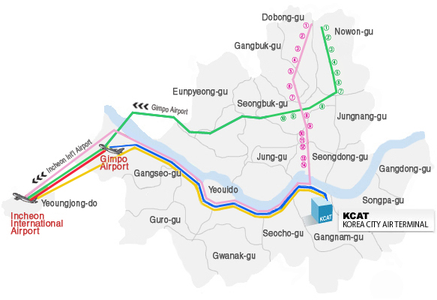
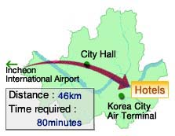

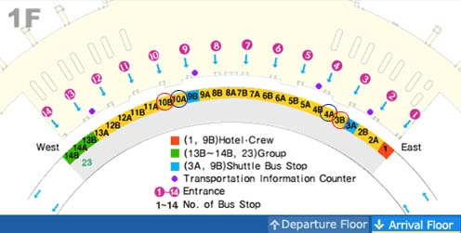

Limousine Bus

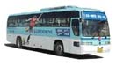
There will be Limousine Buses leaving every 20~30 minutes from the IIA to Hotels and it normally takes about an hour. The buses to the host hotel (COEX INTERCONTINENTAL Seoul) are available at the stop No. 3B or 10B, and the Limousine Bus fare is KRW 12,000 (app. USD10). Information and tickets for the Limousine Bus are available at the Transportation Information Counter on the 1st floor of the airport. We kindly recommend you to use the Limousine Buses. Please refer to the IGARSS 05 website for details.

Deluxe Taxi

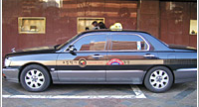
Deluxe Taxis can be found at the taxi stop No. 21 at the IIA. They are called “Mobeom Taxi” in Korean and they have a yellow roof, black body and deluxe taxi sign on both sides. They offer more passenger space and a high standard of service. Fares are KRW 4,000 for the first 3 kilometers and KRW 200 for each additional 205 meters or each 50 seconds if the speed drops below 15 kilometers per hour. The fare from IIA to hotels is approximately KRW 70,000 (app. USD61). Deluxe taxis can be taken at stands located at hotels, stations, bus terminals, and major city streets. They also can be called at ☎ 02-558-8000.

Regular Taxi

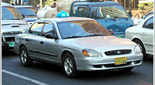
Regular Taxis are available at the taxi stop No. 18 at the IIA. The fare system is based on both distance and time. Fares are KRW1,600 for the first 2 kilometers and KRW 100 for each additional 168 meters. If the taxi is going less than 15kilometers per hour, an additional charge of KRW 100 per 41 seconds is added to the fare.
Average fare from the IIA to hotels is about KRW 50,000 (app. USD44), but it may cost you less or more depending on the traffic during rush hours.

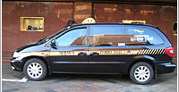
Taxi Vans
Exclusive van Taxis are available at the van Taxi stop No. 17. Van Taxis can accommodate 9 persons at its maximum. They are installed with simultaneous foreign language interpretation by phone, receipt-issuing equipment, and credit card processing terminal. Fares are the same as deluxe taxis. Passenger carrying large amounts of baggage may find them convenient. They can be called at ☎ 02-888-2000.

Brand Taxis
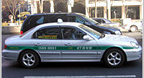
The Brand taxis "Kind Call Taxi" and "KT Powertel" are equipped with a simultaneous interpretation machine, a receipt issuance machine and wireless data terminal with automatic vehicle location system (a 24-hour call center checks real-time taxi availability and dispatches the closest one). The fare is the same as that of regular taxi and 1,000 won is surcharged for call usage.
Kind Call Taxi: ☎ 1588-3382 / KT Powertel: ☎ 1588-0082

*Notice:

- Please note that all metered taxi fares do not include toll fees and a tip, and there is 20% late-night charge between 24:00-04:00.

- Korea City Air Terminal (KCAT) provides air travelers with limousine services from the Incheon International Airport to the World Trade Center Complex where the COEX and the KCAT are located in. It normally takes about an hour and the bus fare is KRW 12,000 (app. USD10). Bus stop numbers are 3B and 10B on the 1st floor of the Incheon International AirpoTI. For more information, please visit the KCAT at http://www.kcat.co.kr

